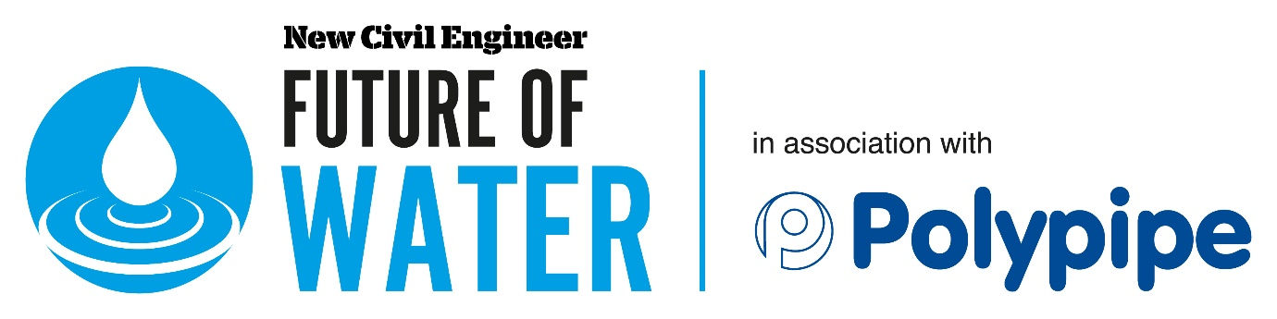
Draft programme
Virtual event, 7 September

Pre-event Discussion – August
Why has the Sewerage Sector Guidance not had the impact expected following its launch and what are the barriers to achieving its aims?
- Why was the guidance bought in and what problems was it trying to solve?
- What does it cover and what are the key differences from the previous guidance?
- What barriers have people experienced in its implementation and why are many projects still not using?
- How can we drive implementation and ensure all levels of the supply chain are engaged?
Chair, Nadine Buddoo, features editor, New Civil Engineer
Nick Ayling, business services and wastewater operations manager, Thames Water
Bronwyn Buntine, sustainable drainage team leader, Kent County Council
Jon Stewart, business development director - drainage, Polypipe
Kenny Mawson, technical director, Persimmon Homes

Main event – 7 September
13:45 Welcome from chair
Claire Smith, editor, New Civil Engineer
13:50 Opening Address – 18 months on from the Sewer Sector Guidance, what is the scope, core aims and how is it having an impact on SuDS?
14:05 Question and answer session
14:10 Project examples: How are projects using the guidance to change approaches to sustainable drainage systems (SuDs) design and management, and ensuring that quality is at the heart of solutions?
14:30 Question and answer session
14:40 Discussion Hub
Delegates select a virtual breakout room where they will hear from a water company as they share their experiences of the SSG, why collaboration is so important to deliver better SuDS and how they will drive quality in the output.
Join the discission to pose your questions to speakers and hear lessons from fellow attendees.
Room 1 | Room 2 | Room 3 | Room 4
Graham Morley, strategy & compliance manager, United Utilities | Jane Pritchard, property solicitor, Southern Water | Speaker TBC | Speaker TBC

15:10 Networking break
15:20 Discussion Hub
Delegates select a virtual breakout room where they will hear from a water company as they share their experiences of the SSG, why collaboration is so important to deliver better SuDS and how they will drive quality in the output.
Join the discission to pose your questions to speakers and hear lessons from fellow attendees.
Room 1 | Room 2 | Room 3 | Room 4
Stephen Wharton, developer services (planning and wastewater) manager, Northumbrian Water | Speaker TBC | Speaker TBC | Speaker TBC

15:50 Panel Discussion
Challenging practices to drive change in the industry’s approach in SuDS in the next six months
- What lessons have we learnt and how will it impact your strategy and priorities?
- What needs to be done to put quality and collaboration at the heart of projects?
- How can we ensure that project specifications meet the guidance requirements?
- How can we all do better at sharing lessons and experiences from SuDS schemes in order to drive positive change?
Jeremy Jones, technical director and practice head of discipline for asset planning & solutions, Atkins
Charlotte Markey, green urbanisation innovation manager, Polypipe

16:35 Closing remarks from chair

EMAP 2021. The programme may change due to unforeseen circumstances. EMAP reserves the right to alter the venue and/or speakers.

